NANYANG POLYTECHNIC
ITI113 — Machine Learning & Operations Project
FINAL REPORT
Real-Time Credit Card Fraud Detection System
A Machine Learning & MLOps Approach to Transaction-Level Fraud Scoring
Team 07
Maung Naing Win Kyaw (4288602M)
Tha Zin Oo (1114879N)
Lionel Tay Choon Thye (5361180E)
Submitted: 27 August 2026

Table of Contents
Table of Contents 2
Executive Summary 4
1.1 Business Problem 5
1.2 ML Framing 5
1.3 Why Accuracy Is Not the Success Metric 5
1.4 Business Objective ↔ ML Objective 5
2. Data Preparation & Feature Engineering 6
2.1 Dataset Overview 6
2.2 Data-Quality and Leakage Audit — Key Finding 6
2.3 EDA Key Findings 7
2.4 Feature Engineering 7
2.5 Train / Validation / Test Split 8
2.6 Bias Identification and Mitigation 8
3. Modelling & Experiments 8
3.1 Business Heuristic Benchmark 8
3.2 Model A — Logistic Regression (Maung Naing Win Kyaw) 9
3.3 Model B — XGBoost (Tha Zin Oo) 9
3.4 Champion Selection and Threshold Calibration 10
3.5 Final Champion Evaluation on the Held-Out Test Set 10
3.6 Error Analysis (Confusion Matrix) 11
3.7 Summary of Modelling Decisions 11
4. ML Operations & Deployment (Lionel Tay Choon Thye) 12
4.1 End-to-End Pipeline Architecture 12
4.2 Experiment Tracking (MLflow) and Model Registry 12
4.3 Governance Control: Manual Approval Gate 12
4.4 Deployment: Real-Time Endpoint 13
4.5 Demo Application 13
4.6 Monitoring — Implemented vs Planned 13
5. Test Report — Responsible AI (Fairness, Explainability, Robustness) 14
5.1 Fairness / Operational Subgroup Consistency 14
5.2 Explainability (SHAP) 15
5.3 Robustness 15
5.4 Limitations of This Test Report 16
6. AI Governance Checklist (ISAGO) 17
7. Project Artifacts 19
8. Individual Contribution 20
9. Conclusion and Next Steps 20
References 22
Appendix 23
Appendix A — Governance and Validation Code Excerpts 23
Appendix B — Screenshots and Evidence 24
Appendix C — Notebook and Artefact Inventory 27

Executive Summary
This report documents the final, end-to-end implementation of the ITI113 project: a real-time credit card fraud detection system, built, evaluated and operationalised on a 50,000-transaction dataset. The team's data-quality and leakage audit found that the supplied Risk_Score feature reconstructs the fraud label with a 100% match rate and therefore excluded it from all modelling; the remaining, leakage-safe feature set was used to train and compare two independent modelling tracks — a Logistic Regression baseline (Model A) and a tuned XGBoost ensemble (Model B) — under a shared, MLflow-tracked experimentation protocol with a stratified 60/20/20 train/validation/test split (random_state = 42).
The XGBoost candidate xgboost_candidate_05 (400 trees, max_depth 5, learning_rate 0.02) was selected as champion after evaluating 10 tracked candidates against a validation false-positive-rate (FPR) target of 4%. Its decision threshold (0.1947) was frozen on validation data alone and then evaluated once, unchanged, on the untouched 10,000-row held-out test set, achieving 63.68% recall and 4.01% FPR — both within the project's deployment gates (recall ≥ 60%, FPR ≤ 5%) — with 88.30% precision and an F1 score of 73.98%.
The champion was operationalised through a three-step SageMaker Pipeline (data audit/preprocessing → training → staging registration) that registers every run to the SageMaker Model Registry as PendingManualApproval; production approval and endpoint creation are deliberately blocked in code and require a human reviewer to type an explicit confirmation before an endpoint is created. The approved model is served through a live SageMaker real-time endpoint and demonstrated through a Gradio web application running inside SageMaker Studio.
A dedicated Responsible-AI audit (Notebook 05) tested the deployed champion for operational fairness across Location, Device Type and Authentication Method, for global and local explainability using SHAP, and for robustness under noise, unseen categories, missing values, out-of-range inputs and malformed requests. The audit surfaced two concrete monitoring items (elevated false-positive rates for Mumbai and for Tablet transactions) and one clear model limitation (extreme sensitivity to the Failed_Transaction_Count_7d feature), which are reported transparently rather than omitted, together with a completed 11-question ISAGO AI governance checklist.

1. ML Formulation

1.1 Business Problem
Card issuers must decide, within milliseconds, whether to approve, hold for review, or decline a transaction. Purely rule-based fraud engines (fixed amount thresholds, velocity checks, merchant blacklists) are transparent but brittle: they generate high false-positive rates that frustrate legitimate customers and are slow to adapt to new fraud patterns. This project frames fraud detection as a supervised machine learning problem so that subtler, non-linear combinations of transaction features can be learned, while still benchmarking the model against a simple rule-based heuristic to justify the additional complexity.

1.2 ML Framing
Aspect | Details
Task type | Supervised binary classification
Input | 16 raw transaction-level fields per transaction (amount, timestamp, account, device, merchant, card, authentication and behavioural-history fields) — see Section 2.4
Output | Fraud probability score in [0, 1] → binary decision (Fraud / Non-fraud) via a frozen probability threshold (0.1947)
Model family evaluated | Model A: Logistic Regression (linear, interpretable baseline). Model B: XGBoost (gradient-boosted tree ensemble, champion)
Class balance (actual dataset) | 32.1% fraud / 67.9% legitimate — imbalanced but far less extreme than typical real-world card fraud (<1%)
Alternative / heuristic baseline | Deployable rule: Failed_Transaction_Count_7d ≥ 3 OR (IP_Address_Flag = 1 AND Previous_Fraudulent_Activity = 1) — used only as a benchmark, never as a champion candidate
Primary success metrics | Recall (fraud caught) subject to a false-positive-rate ceiling, precision, F1, ROC-AUC, PR-AUC — accuracy is explicitly not used as a selection metric given class imbalance
Deployment decision rule | predicted_probability ≥ decision_threshold → Fraud; otherwise → Non-fraud

1.3 Why Accuracy Is Not the Success Metric
With roughly one in three transactions fraudulent, a model that always predicts “legitimate” would still be 67.9% accurate while catching zero fraud. The team therefore selected models and thresholds using recall at a fixed, conservative false-positive-rate budget, and reports precision, F1, ROC-AUC and PR-AUC as secondary evidence, consistent with the module's post-progress-check guidance to avoid relying on accuracy for imbalanced problems.

1.4 Business Objective ↔ ML Objective
The business objective — minimise fraud losses without alienating legitimate customers with false declines — is translated into two hard operating constraints agreed by the team and logged in every MLflow run: recall must be at least 60% (catch a majority of fraud) and the false-positive rate at final deployment must not exceed 5% (no more than 1 in 20 legitimate transactions is wrongly flagged). Threshold selection additionally uses a stricter 4% validation-FPR target to leave a generalisation margin below the 5% deployment ceiling.

2. Data Preparation & Feature Engineering

2.1 Dataset Overview
Source: Kaggle “Fraud Detection Transactions Dataset” (samayashar) — https://www.kaggle.com/datasets/samayashar/fraud-detection-transactions-dataset. Following lecturer feedback after the Proposal stage, the team replaced the originally proposed PCA-anonymised ULB/Worldline-style proxy design with this fully-labelled, feature-interpretable dataset, trading an extreme (<1%) real-world imbalance for genuine feature interpretability — a deliberate, documented trade-off.
Property | Value
Rows × columns | 50,000 transactions × 21 columns
Unique users / transactions | 8,963 users / 50,000 unique Transaction_ID (no duplicates)
Missing values | 0 across all columns
Duplicate rows | 0
Date range | 1 Jan 2023 – 31 Dec 2023
Target column | Fraud_Label (0 = legitimate, 1 = fraud)
Class balance | 33,933 legitimate (67.9%) / 16,067 fraud (32.1%)

2.2 Data-Quality and Leakage Audit — Key Finding
Before any modelling, the team ran an automated data-quality and leakage audit (Notebook 02, Section 3). Two material issues were uncovered and both are treated as governance-relevant findings, not implementation footnotes:
- Target leakage via Risk_Score: the explicit rule (Risk_Score > 0.85) OR (Failed_Transaction_Count_7d ≥ 4) reproduces Fraud_Label with a 100.00% match rate. This means Risk_Score is very likely a derivative of the label itself rather than a genuine pre-transaction signal. Risk_Score was therefore permanently excluded from every model, the pipeline's training script and the deployed inference contract — a decision enforced in code (train.py raises an error if Risk_Score is present) as well as in the report.
- Inconsistent Is_Weekend field: the supplied Is_Weekend column disagreed with the value derived from Timestamp for 20,755 rows (41.5%). The supplied column was discarded and replaced with a Derived_Is_Weekend feature computed directly from Timestamp.
Failed_Transaction_Count_7d was retained under the documented assumption that it is a historical value available before the current transaction is scored (i.e. it does not leak the current outcome); this assumption is treated as a modelling caveat rather than a proven fact, and its unusually strong influence on the champion model is revisited in Sections 3.6 and 5.3.

2.3 EDA Key Findings
Correlation with the target (numeric features, Risk_Score excluded from modelling but shown for context):
Feature | Correlation with Fraud_Label | Interpretation
Failed_Transaction_Count_7d | 0.51 | Strong positive linear relationship with fraud
Risk_Score (Exclude) | 0.39 | Moderate positive linear relationship with fraud
Daily_Transaction_Count | -0.01 | Negligible linear relationship with fraud
Account_Balance | 0 | Negligible linear relationship with fraud
Card_Age | 0 | Negligible linear relationship with fraud
IP_Address_Flag | 0 | Negligible linear relationship with fraud
Transaction_Amount | 0 | Negligible linear relationship with fraud
Previous_Fraudulent_Activity | 0 | Negligible linear relationship with fraud
Avg_Transaction_Amount_7d | 0 | Negligible linear relationship with fraud
Transaction_Distance | 0 | Negligible linear relationship with fraud
Is_Weekend | 0 | Negligible linear relationship with fraud

Every categorical feature tested (Transaction_Type, Device_Type, Merchant_Category, Card_Type, Authentication_Method, Location, Previous_Fraudulent_Activity, IP_Address_Flag) showed a near-uniform fraud rate of 31–33%, indicating weak independent predictive power. This was treated as a genuine EDA finding rather than an oversight: it directed the modelling effort toward Failed_Transaction_Count_7d and interaction/time-based engineering rather than toward categorical main effects, and it is later corroborated independently by the SHAP global-importance results in Section 5.2 (no Location, Card Type or Authentication Method field appears among the top 15 globally important features).

2.4 Feature Engineering
A single, explicit “deployable feature policy” (deployable_v2_exclude_risk_score_keep_historical_failed_count) is shared by the experimentation notebook, the training-pipeline script and the inference code, guaranteeing training/serving consistency:
- Removed: Transaction_ID, User_ID (identifiers), Risk_Score (leakage), the supplied Is_Weekend (data-quality issue), and the raw Timestamp string once engineered features are derived.
- Engineered from Timestamp: Transaction_Hour, Transaction_DayOfWeek, Transaction_Month, Derived_Is_Weekend, and cyclical encodings Transaction_Hour_Sin / Transaction_Hour_Cos (so that 23:00 and 00:00 are treated as numerically adjacent).
- Final model feature set: 15 numeric features (StandardScaler for Logistic Regression; passthrough for XGBoost) + 6 categorical features (one-hot encoded, unknown categories safely ignored at inference time).
- 16 raw fields form the exact inference contract exposed to the demo application and the deployed endpoint (Section 4.5); Risk_Score, Fraud_Label, Transaction_ID, User_ID and Is_Weekend are explicitly rejected if supplied by a caller.

2.5 Train / Validation / Test Split
A stratified random 60/20/20 split (random_state = 42) produced Train = 30,000 rows, Validation = 10,000 rows and Test = 10,000 rows, each preserving the 32.1% fraud rate. Per the module's post-progress-check guidance, the test split was kept completely untouched until model selection, hyperparameter comparison and threshold selection were finished on validation data alone (Section 3); it was used exactly once, at the very end, to report the final numbers in Section 3.6.

2.6 Bias Identification and Mitigation
At the data-preparation stage, potential bias was addressed in two ways: (1) the categorical near-uniformity finding in Section 2.3 was used to avoid over-weighting demographically-adjacent fields (e.g. Location) as if they were strong fraud predictors on their own; and (2) because the dataset contains no protected demographic attributes (no sex, age, race, or disability field), the team scoped bias review to operational subgroups that are present in the data — Location, Device_Type and Authentication_Method — and mitigated the risk of over-claiming fairness by explicitly documenting this as an operational-consistency check, not a demographic-fairness guarantee. The full subgroup audit and its results are reported in Section 5.1.

3. Modelling & Experiments
All experiments were tracked in a shared SageMaker-hosted MLflow App (experiment ITI113/team07/Experiment1, set up in Notebook 01) so that every run's parameters, metrics, plots and model artefact are reproducible from a run ID. Every run is tagged with course, team, dataset version, split strategy and the shared quality-gate targets (validation FPR target = 4%, minimum acceptable recall = 60%, maximum deployment FPR = 5%).

3.1 Business Heuristic Benchmark
A deployable rule-based heuristic (Failed_Transaction_Count_7d ≥ 3 OR (IP_Address_Flag = 1 AND Previous_Fraudulent_Activity = 1)) was logged as a benchmark only — it is not eligible for champion selection. On validation data it reached 71.09% recall but at a 24.94% false-positive rate, with 57.43% precision and an F1 of 63.53%. This result is the core justification for using machine learning: the heuristic catches somewhat more fraud than the eventual ML champion, but at roughly six times the false-positive cost, which would translate into a very large volume of legitimate customers being wrongly flagged.

3.2 Model A — Logistic Regression (Maung Naing Win Kyaw)
Hypothesis: a regularised linear model on the leakage-safe, standardised feature set should already recover most of the signal in Failed_Transaction_Count_7d and a handful of engineered time features, giving a fast, interpretable baseline against which the more expressive Model B can be judged. Four candidates were trained (L2 regularisation strength C ∈ {0.1, 1.0} × class_weight ∈ {None, balanced}), each evaluated once on validation data at its own FPR-targeted threshold:
Candidate | C | class_weight | Val. recall | Val. FPR | Val. F1
logistic_candidate_01 | 0.1 | None | 63.03% | 3.90% | 0.7360
logistic_candidate_02 | 1.0 | None | 63.03% | 3.99% | 0.7352
logistic_candidate_03 | 0.1 | balanced | 63.12% | 3.98% | 0.7360
logistic_candidate_04 | 1.0 | balanced | 63.09% | 3.98% | 0.7358

Observation: class weighting made almost no measurable difference at this class balance (32% fraud is mild enough that Logistic Regression does not need explicit re-weighting), and all four candidates converge to essentially the same operating point (~63% recall at ~4% FPR). This is a useful negative result: it shows the earlier proposal's assumption that heavy imbalance-handling (SMOTE, aggressive class weighting) would be required was no longer applicable once the dataset was replaced (Progress Check, Section 2.1).

3.3 Model B — XGBoost (Tha Zin Oo)
Hypothesis: a gradient-boosted tree ensemble can exploit non-linear interactions (e.g. between Failed_Transaction_Count_7d and time-of-day features) that a linear model cannot, and may therefore achieve a better recall/FPR trade-off than Model A at the same operating point. Three tree structures (shallow/wide to deeper/narrower) were each tested with scale_pos_weight fixed at 1.0 and at the observed training-class ratio (≈2.11), for six candidates in total:
Candidate | Structure (trees/depth/lr) | scale_pos_weight | Val. recall | Val. FPR | Val. F1
xgboost_candidate_01 | 150 / 3 / 0.05 | 1.00 | 62.84% | 3.79% | 0.7357
xgboost_candidate_02 | 150 / 3 / 0.05 | 2.11 (obs.) | 62.90% | 3.82% | 0.7358
xgboost_candidate_03 | 250 / 4 / 0.03 | 1.00 | 63.03% | 3.98% | 0.7353
xgboost_candidate_04 | 250 / 4 / 0.03 | 2.11 (obs.) | 62.87% | 3.68% | 0.7368
xgboost_candidate_05 (champion) | 400 / 5 / 0.02 | 1.00 | 63.12% | 3.92% | 0.7365
xgboost_candidate_06 | 400 / 5 / 0.02 | 2.11 (obs.) | 63.09% | 3.79% | 0.7375

Observation: The hypothesis was only partly confirmed. XGBoost’s strongest candidates achieved approximately the same validation-recall range as Logistic Regression rather than a clearly superior result. Candidate 05 matched Logistic Regression’s best recall (63.12%) while achieving a slightly lower validation FPR (3.92% versus 3.98%). This lower FPR broke the tie under the predefined selection rule, so candidate 05 was selected as the champion. Overall, XGBoost provided only a marginal improvement, and the results do not demonstrate that the hypothesised nonlinear time-of-day interactions contributed materially.

3.4 Champion Selection and Threshold Calibration
All 10 tracked candidates (4 Logistic Regression + 6 XGBoost) were compared on validation data using a fixed selection rule, agreed and logged before any test-set evaluation: keep only candidates with validation FPR ≤ 4%, then rank by (1) highest recall, (2) lowest FPR, (3) highest F1, (4) highest precision. All 10 candidates satisfied the FPR ≤ 4% eligibility bar. xgboost_candidate_05 ranked first — tied for the best recall (63.12%) with logistic_candidate_03, but with a lower FPR (3.92% vs 3.98%) — and was selected as champion, with its decision threshold frozen at 0.1947.
The team's Focus-Area-C member communicated the threshold rationale to the team on 24 August 2026 (Appendix B, Fig. B.1): the project's original 0.70 recall aspiration (set in the Proposal, before the leakage-prone Risk_Score was known to require exclusion) was found not to be feasible once Risk_Score was correctly excluded. Threshold selection therefore uses a 4% validation-FPR target — tighter than the 5% final deployment ceiling — to provide a generalisation margin, while the prototype recall gate (≥ 60%) and the final deployment FPR gate (≤ 5%) were kept unchanged rather than relaxed to fit the result.

3.5 Final Champion Evaluation on the Held-Out Test Set
The frozen threshold (0.1947) was applied, unchanged, to the 10,000-row test split that had not been touched during model or threshold selection:
Metric | Result | Meaning
Recall | 63.68% | Fraud transactions correctly caught
False-positive rate | 4.01% | Legitimate transactions incorrectly flagged
Precision | 88.30% | Fraud alerts that were genuinely fraudulent
F1 score | 73.98% | Balance between recall and precision
Accuracy | 85.62% | Reported for completeness — not used for model selection
Balanced accuracy | 79.84% | Average of per-class recall
ROC-AUC | 81.34% | Threshold-independent ranking quality
PR-AUC | 80.93% | Threshold-independent ranking quality under imbalance
Matthews correlation coefficient | 66.06% | Overall correlation between prediction and label

Both deployment gates were satisfied — recall 63.68% ≥ 60% and FPR 4.01% ≤ 5% — so the champion was marked deployment_ready = true and eligible for staging registration (Section 4).

3.6 Error Analysis (Confusion Matrix)
 | Predicted Non-fraud | Predicted Fraud
Actual Non-fraud (6,787) | 6,515 (TN) | 272 (FP)
Actual Fraud (3,213) | 1,167 (FN) | 2,046 (TP)

1,167 fraudulent transactions (36.3% of all fraud in the test set) were missed, and 272 legitimate transactions (4.0% of legitimate test transactions) were wrongly flagged. The Responsible-AI audit in Section 5.2 traces a representative false negative directly to Failed_Transaction_Count_7d = 0 — i.e. the champion systematically struggles with “first-time” fraud attempts that have no prior failed-transaction history, because that single feature dominates its decisions (mean |SHAP| = 2.2715, roughly 55× the next most important feature). This is documented here as the model's principal limitation rather than only as a headline metric.

3.7 Summary of Modelling Decisions
The progression required by the module — baseline → Model A / Model B → tuning → controlled comparison → final champion decision — is summarised as: (1) a rule-based heuristic benchmark showed ML was worth pursuing; (2) Model A (4 candidates) and Model B (6 candidates) were tuned under an identical, fair evaluation protocol (same split, same validation-FPR selection rule, same eligibility bar); (3) both families converged to a similar ceiling (~63% recall at ~4% FPR), which is itself an important, honestly-reported finding rather than a tuning failure; (4) XGBoost candidate_05 was selected on a small but real margin (lower FPR at equal recall); (5) its threshold was frozen on validation data and confirmed, unchanged, on the untouched test set.

4. ML Operations & Deployment (Lionel Tay Choon Thye)

4.1 End-to-End Pipeline Architecture
The deployed system implements one clear end-to-end MLOps flow: data ingestion → preprocessing/audit → training → evaluation → experiment tracking → model registration → manual approval → deployment → inference. It spans five notebooks: Notebook 01 provisions the shared MLflow tracking backend; Notebook 02 performs EDA, model development and champion selection (Section 3); Notebook 03 operationalises the champion through a repeatable SageMaker Pipeline and manages registry, approval and deployment; Notebook 04 exposes the approved endpoint through a demo application; Notebook 05 audits the deployed champion for fairness, explainability and robustness (Section 5).

4.2 Experiment Tracking (MLflow) and Model Registry
A dedicated SageMaker MLflow App (iti113-26s1-team07-mlflow-app, tagged Course/Semester/TeamId/StudentId/ProjectName) stores every run's parameters, metrics, plots (confusion matrix, ROC curve) and the serialised model pipeline, with artefacts written to s3://nyp-26s1-iti113/iti113/team07/mlflow-app-artifacts/. This satisfies the module's requirement that a run can be reproduced from its recorded parameters, metrics, model version, data version, preprocessing configuration and run ID.
The SageMaker Pipeline (named iti113-team07-credit-card-fraud-detection) has three steps:
- AuditAndPreprocessData (SKLearnProcessor, ml.m5.large) — re-runs the same schema/leakage audit and stratified 60/20/20 split inside the pipeline, so the pipeline can never silently diverge from the Notebook 02 experiment that selected the champion.
- TrainLeakageSafeChampion (SKLearn Estimator, ml.m5.large) — retrains the exact champion algorithm and hyperparameters (passed as pipeline parameters) on the pipeline's own processed data and re-evaluates it on its own held-out test split, emitting the same metric set as Notebook 02 (recall, FPR, precision, F1, ROC-AUC, PR-AUC, MCC) via CloudWatch-parsed training metrics.
- RegisterStagingCandidate (ModelStep) — packages the trained model with its inference code and registers it to the SageMaker Model Registry group team07-credit-card-fraud-detection with ModelApprovalStatus = PendingManualApproval and a Staging lifecycle tag.

The pipeline was executed repeatedly during development (8 completed executions between 21 and 24 August 2026, each completing its Processing and Training steps in about 3 minutes — Appendix B, Fig. B.4 and Fig. B.5), demonstrating that it is repeatable and idempotent, which is the practical basis for a CI/CD-style workflow even though an automated trigger (e.g. firing on new data landing in S3) was not wired up in this submission — see Section 4.6.

4.3 Governance Control: Manual Approval Gate
A deliberate, code-enforced governance control sits between training and deployment: ALLOW_PRODUCTION_APPROVAL and ALLOW_ENDPOINT_DEPLOYMENT are both hard-coded to False inside Notebook 03, so the notebook itself is structurally incapable of auto-approving a model package or auto-creating an endpoint, regardless of how good its metrics are. Instead, a team member must open Notebook 03, Section 11 (“Review and Manually Approve the Staging Model Package”), inspect the quality-gate result, and type the literal confirmation string APPROVE before ModelApprovalStatus is changed to Approved; only Section 13 can then create a live endpoint from an Approved package. This exchange was confirmed within the team on 24 August 2026 (“Need Manual Review required for endpoint creation. In Notebook 3 – Section 12 (Manual Approve) will need input to proceed endpoint creation.” — Appendix B, Fig. B.1), and directly implements the level-of-human-involvement control required by ISAGO Question 2 (Section 6).

4.4 Deployment: Real-Time Endpoint
Once approved, Section 13 creates a SageMaker Model, EndpointConfig and Endpoint (ml.m5.large) and waits for InService status before returning control. The endpoint used for the Notebook 04 demo and Final Presentation is team07-fraud-v12-endpoint-1787553989 (Model Registry package version 12, XGBoost, deployment_ready = true), validated in Notebook 03, Section 13 with a live sample prediction that returned a 15.83% fraud probability against the 0.1947 threshold (correctly Non-fraud). The AWS Console model listing (Appendix B, Fig. B.2) shows the version history — v9, v11 and v12 — produced by repeated pipeline runs and approvals between 11 and 24 August 2026, evidencing an iterative, auditable release process rather than a single untracked deployment.

4.5 Demo Application
A Gradio Blocks application (Notebook 04) is served through the SageMaker Studio Jupyter-Server-Proxy, so it runs inside the authenticated Studio session rather than being exposed on the public internet. On start-up it discovers InService endpoints tagged with the team ID, loads the champion's exact 16-field raw_inference_columns contract from the same JSON file the pipeline uses, and builds a guided form (dropdowns populated from observed categorical values, numeric fields, a parseable timestamp field) with one-click “Normal example” / “Fraud example” loaders drawn from the approved dataset. On submission it re-validates the payload against the same forbidden-field / missing-field contract used by the deployed inference.py, invokes the live SageMaker Runtime endpoint, and displays the fraud probability, the frozen decision threshold, and the resulting label with the decision rule spelled out (Appendix B, Fig. B.3).

4.6 Monitoring — Implemented vs Planned
Per the module's post-progress-check guidance to clearly distinguish implemented, tested and planned items, the team reports monitoring status honestly rather than as fully complete:
Component | Status | Evidence / Notes
Experiment tracking (MLflow) | Implemented | Every run logged with parameters, metrics, plots and model artefact (Section 4.2)
Model registry | Implemented | SageMaker Model Registry group with versioned packages (Fig. B.2)
Manual approval gate | Implemented | Code-enforced; verified 24 Aug 2026 (Fig. B.1, Section 4.3)
Repeatable pipeline (CI/CD-style) | Implemented | 8 successful re-runs, 21–24 Aug 2026 (Figs. B.4–B.5)
Automated pipeline trigger | Planned, not implemented | Manually started in this submission; no S3-event or schedule trigger wired up
Data / model drift monitoring (SageMaker Model Monitor + CloudWatch, DataCaptureConfig) | Planned, not implemented | Scoped in the Proposal and Progress Check; not present in the current Notebook 03 pipeline — see Section 9 (Conclusion / Next Steps)
Input-range validation at the API layer | Gap identified by testing | Robustness testing (Section 5.3) found the model layer accepts out-of-range numeric inputs; the raw-contract layer already rejects missing/invalid fields

5. Test Report — Responsible AI (Fairness, Explainability, Robustness)
Notebook 05 provides the team's AI Verify–style test report. It reconstructs the identical leakage-safe test split, loads the champion from its recorded MLflow run, and evaluates it at its frozen threshold — the model is never retrained and the threshold is never retuned in this notebook.

5.1 Fairness / Operational Subgroup Consistency
The dataset contains no sex, age, race, disability or other protected demographic attribute, so this audit evaluates operational subgroup consistency using Fairlearn's MetricFrame across Location, Device_Type and Authentication_Method, rather than demographic fairness. Results should not be presented as proof of fairness in a real banking population.
Subgroup dimension | Recall range (gap) | FPR range (gap) | Gate breach
Location | 62.35% (New York) – 64.66% (Tokyo) [2.31pp] | up to 5.24% (Mumbai) [1.63pp] | Mumbai FPR 5.24% > 5% gate
Device_Type | 62.28% (Mobile) – 64.79% (Tablet) [2.51pp] | 2.73% (Laptop) – 6.05% (Tablet) [3.32pp] | Tablet FPR 6.05% > 5% gate; lowest precision 83.99%
Authentication_Method | 61.29% (Biometric) – 65.49% (OTP) [4.20pp] | 3.45% (Biometric) – 4.85% (OTP) [1.39pp] | None — all groups meet both gates

Interpretation: all subgroups meet the 60% recall gate everywhere. Two operational disparities exceed the project's 5% FPR gate — Mumbai transactions and Tablet transactions both carry a higher risk of unnecessary manual review — and are reported here as monitoring items rather than hidden. Authentication method shows the largest recall gap (4.20pp) but no gate breach. Because Location, Device_Type and Authentication_Method are operational rather than protected attributes, and the dataset is synthetic, these results characterise operational consistency, not demographic fairness; real-world validation with genuine protected attributes would still be required before production use.

5.2 Explainability (SHAP)
SHAP TreeExplainer was applied to the champion's XGBoost classifier on a fixed, reproducible 1,000-row sample of the transformed test features (40 one-hot/numeric columns), giving both global and local (case-level) explanations, which the module requires alongside fairness and robustness testing.
Global finding: Failed_Transaction_Count_7d dominates the model, with a mean absolute SHAP value of 2.2715 — roughly 55× larger than the second-ranked feature, Transaction_Distance (0.0416). Device_Type_Tablet ranked ninth (0.0221), consistent with its elevated FPR in Section 5.1, but no Location, Card_Type or Authentication_Method indicator appears among the top 15 globally important features, which corroborates the EDA finding in Section 2.3 that categorical fields carry little independent predictive power. This extreme concentration on one feature is reported as a model and dataset limitation, not a strength.
Local case studies (waterfall explanations for one true positive, one false negative and one false positive): a correctly-caught fraud (probability 99.91%) was driven almost entirely by Failed_Transaction_Count_7d = 4 (contribution ≈ +7.79); a missed fraud (false negative, probability 15.71%) had Failed_Transaction_Count_7d = 0, which pushed the score down by ≈ −0.99 despite other weaker upward contributors — illustrating that fraud without a prior failed-transaction history is systematically under-detected; a false positive (probability 19.96%, only 0.49pp above the 19.47% threshold) resulted from several small contributions (account balance, transaction distance, day-of-week, OTP authentication) combining on an otherwise low-risk transaction, illustrating the practical cost of borderline cases — an unnecessary decline, delay or manual review.

5.3 Robustness
Controlled perturbations of the held-out test set were evaluated with the model and threshold held fixed, reusing the project's own recall ≥ 60% / FPR ≤ 5% gates as team-defined robustness criteria (the assignment does not prescribe numerical robustness thresholds).
Perturbation | Result | Gates
Baseline (unperturbed test set) | Recall 63.68%, FPR 4.01%, F1 73.98% | Pass
±5% multiplicative noise on 4 continuous fields | 2.10% of predictions flipped; F1 −0.63pp; recall −0.31pp; FPR +0.44pp | Pass
10% of Device_Type set to an unseen category | Only 0.10% of predictions flipped (handled via handle_unknown="ignore"); F1 +0.03pp | Pass
Failed_Transaction_Count_7d forced 3 → 4 (all rows) | 94.01% of decisions changed; mean fraud probability jumped 15.66% → 99.91% | Forced-3: recall collapses to 6.50%. Forced-4: recall & FPR both 100% (deliberately severe stress test)
5% of Transaction_Amount set missing | Model layer: only 0.09% of predictions changed. Raw-request layer: missing amount safely rejected before reaching the model | Pass (model); reject is correct behaviour (contract)
5% of rows given out-of-range values (negative amount, extreme distance, daily count = 99) | FPR rose from 4.01% to 6.60%; precision −5.99pp; F1 −1.54pp | Fail — FPR gate breached; identifies a real gap (Section 4.6)
Malformed raw requests (missing field, invalid timestamp, negative amount) | All three safely rejected with a clear error; a valid record was accepted | Pass — correct fail-fast behaviour

Interpretation: the champion is stable under small numeric noise and an unseen categorical value, but it is highly sensitive to the Failed_Transaction_Count_7d boundary (consistent with the SHAP finding above) and is not adequately protected against out-of-range numeric inputs at the model layer — only the raw-request contract currently performs fail-fast validation. This robustness gap and the input-range-validation gap noted in Section 4.6 are the same finding reported from two different angles, and are carried into Section 9 as a concrete next step rather than left implicit.

5.4 Limitations of This Test Report
- No demographic protected attributes are available in the dataset, so fairness results describe operational consistency, not legally protected fairness.
- The dataset is synthetic; results cannot be presented as proof of real-world fairness or robustness.
- SHAP explains how the fitted model used its inputs, not what causes fraud in the real world.
- Robustness pass/fail criteria are the team's own project gates, not an externally mandated standard.

6. AI Governance Checklist (ISAGO)
This assessment follows the Model AI Governance Framework (2nd Edition) and the Implementation and Self-Assessment Guide for Organisations (ISAGO), published by IMDA and PDPC, using the 11-question subset prescribed for ITI113 projects. The table below reflects the completed, final-report status of the checklist (superseding the forward-looking, “will be” answers submitted at the Proposal stage).
# | Question (summary) | Stage | Resp. | Remarks
1 | Has your project team defined a clear purpose in using the identified AI solution? | Initiation | YES | Purpose defined and unchanged since the Proposal: score individual card transactions in near real time and route them to an automated allow / manual-review / block decision, reducing fraud losses and false declines relative to the prior rule-based approach (Section 1).
2 | Did your project team implement the appropriate level of human involvement in AI-augmented decision-making? | Implementation | YES | Implemented and code-enforced: every model package is registered PendingManualApproval and cannot be auto-approved or auto-deployed (ALLOW_PRODUCTION_APPROVAL / ALLOW_ENDPOINT_DEPLOYMENT = False). A human must type APPROVE in Notebook 03, Section 11–12 before an endpoint can be created (Section 4.3, Fig. B.1).
3 | For safety-critical systems, can relevant personnel assume control and is sufficient information provided? | Implementation | NA | Not applicable — this is a decision-support / queueing system for card transactions, not a safety-critical autonomous control system. Flagged transactions still route to a human review queue rather than being auto-blocked without recourse.
4 | Did your project team adopt best practices in data management and protection? | Initiation | YES | Dataset stored only under the team's private S3 prefix (s3://nyp-26s1-iti113/iti113/team07/…) and the MLflow App's artefact store, both scoped to the Team07 SageMaker execution role; no public distribution of raw data.
5 | Is the dataset used relevant? | Implementation | YES | Kaggle “Fraud Detection Transactions Dataset” (50,000 credit-card transactions, 21 features) is directly relevant, confirmed by the automated audit and EDA in Notebook 02 (Section 2).
6 | Where personal data is involved, is it collected for the intended purposes? | Implementation | NA | No real personal data is processed. Transaction_ID and User_ID are synthetic keys with no linkage to real individuals; both are excluded from every model as identifiers (Section 2.4).
7 | Is the dataset used well-structured and in a machine-understandable form? | Implementation | YES | Standard CSV, 50,000 rows × 21 columns, zero missing values, zero duplicate rows — confirmed by the automated data-quality audit (Notebook 02, Section 3.1).
8 | If the dataset was joined from multiple sources, were extraction/transformation operations performed correctly? | Implementation | NA | Not applicable — a single source dataset was used; no join was required.
9 | Did your project team identify and propose solutions to mitigate unintended biases in the dataset, especially omission and stereotype bias? | Implementation | YES | (a) Leakage audit found Risk_Score reconstructs the label 100% of the time and excluded it (Section 2.2); (b) EDA found near-uniform 31–33% fraud rates across all categorical fields, ruling out an obvious categorical proxy (Section 2.3); (c) a formal Fairlearn subgroup audit (Section 5.1) surfaced two concrete FPR disparities (Mumbai, Tablet) that are documented as monitoring items rather than concealed.
10 | Did your team use different datasets for training, testing and validation of the AI model? | Implementation | YES | Stratified 60/20/20 split (random_state = 42); the test split was held out and untouched until champion selection and threshold-freezing were complete (Section 2.5, 3.4–3.5).
11 | Can your project team explain how the deployed AI model functions and arrives at a particular prediction? | Implementation | YES | Global (SHAP beeswarm/bar) and local (SHAP waterfall for a true-positive, false-negative and false-positive case) explanations were produced (Section 5.2); the demo application also surfaces the fraud probability and decision threshold alongside every live prediction (Section 4.5).

Project name: Real-Time Credit Card Fraud Detection. Project description: card-not-present and point-of-sale fraud is a significant source of direct financial loss and customer-trust erosion for card issuers and payment processors; this project builds, deploys and operationalises a machine-learning-based fraud detection system that scores individual transactions in near real time and routes them to an automated allow / manual-review / block decision.

7. Project Artifacts
All code, tracking and deployment artefacts run inside the class AWS account (ap-southeast-1) under the Team07 SageMaker execution role and are not public-internet-facing, consistent with the classroom security policy (ISAGO Q4, Section 6). The following are submitted with this report:
Artefact | Reference
Source code (Jupyter notebooks) | - ITI113-MLOps Project-01-Setup.ipynb  - ITI113-MLOps Project-02-Experiments.ipynb  - ITI113-MLOps Project-03-Pipeline.ipynb  - ITI113-MLOps Project-04-App.ipynb  - ITI113-MLOps Project-05-Responsible-AI.ipynb  — submitted alongside this report in the assignment ZIP
Dataset | credit_card_fraud.csv (fraud_dataset.csv), submitted alongside this report; original source: Kaggle “Fraud Detection Transactions Dataset” (Section 2.1)
Experiment tracking | SageMaker MLflow App iti113-26s1-team07-mlflow-app, experiment ITI113/team07/Experiment1 (Section 4.2) — accessible to the Team07 role via a short-lived presigned URL generated from Notebook 01; screenshots of runs are provided as evidence rather than a persistent public link
Model registry | SageMaker Model Package Group team07-credit-card-fraud-detection (Fig. B.2)
Live endpoint (Final Presentation) | team07-fraud-v12-endpoint-1787553989 — InService, Model Package version 12, XGBoost champion (Section 4.4)
Demo application | Gradio app in Notebook 04, served via the SageMaker Studio Jupyter-Server-Proxy inside the authenticated Team07 Studio space (Fig. B.3); not internet-public by design
Responsible-AI evidence | responsible_ai_outputs/ directory generated by Notebook 05 (fairness tables, SHAP plots, robustness tables, JSON summary) — referenced throughout Section 5
Presentation slides | Submitted separately for the 26 August 2026 Final Presentation, per the module's ZIP submission checklist

8. Individual Contribution
Contributions follow the focus-area allocation agreed in the Project Proposal (Section 7 of that document) and confirmed unchanged in the Progress Check Report. All three members jointly own Data & EDA framing (Focus Area A) and Analysis & Communication (Focus Area D); each member leads one primary focus area and contributed the corresponding governance items.
Team member | Primary focus area | Report sections authored | Key deliverables
Maung Naing Win Kyaw (4288602M) | Model Development — Model A (Focus Area B) | Sections 1, 2, 3.1–3.2, 3.4, 3.7; overall report compilation and editing | Logistic Regression candidate tuning (Notebook 02, Section 9); leakage/EDA audit execution and write-up; ML formulation; model-level AI-governance items (bias/explainability framing for Model A)
Tha Zin Oo (1114879N) | Model Development — Model B (Focus Area B) | Sections 3.3, 3.5–3.6 | XGBoost candidate tuning (Notebook 02, Section 10); champion comparison and threshold-selection analysis; test-set error analysis
Lionel Tay Choon Thye (5361180E) | MLOps & Deployment (Focus Area C) | Sections 4, 5, 6 (system-level items), 7 | MLflow App setup (Notebook 01); SageMaker Pipeline, Model Registry, manual-approval governance and endpoint deployment (Notebook 03); Gradio demo application (Notebook 04); Responsible-AI fairness/explainability/robustness testing (Notebook 05)

All three members jointly reviewed the completed ISAGO checklist (Section 6), the Executive Summary and the Conclusion, and jointly prepared the Final Presentation.

9. Conclusion and Next Steps
The team delivered a complete, evidence-backed pipeline from raw data to a governed, deployed, and tested fraud-detection system. The leakage-safe XGBoost champion meets both project deployment gates on an untouched test set (63.68% recall, 4.01% FPR), is registered through a repeatable SageMaker Pipeline with a code-enforced human-approval gate, is served through a live endpoint, and is demonstrated through a working Gradio application. A dedicated Responsible-AI audit tested fairness across three operational subgroups, produced global and local explanations, and stress-tested the model under six perturbation scenarios — reporting two FPR disparities (Mumbai, Tablet) and an out-of-range-input gap transparently rather than omitting them, consistent with the module's explicit guidance to distinguish implemented, tested and planned work.
Recommended next steps, carried forward from Sections 4.6 and 5.3 rather than newly introduced here:
- Implement SageMaker Model Monitor with DataCaptureConfig and CloudWatch alerting for input and prediction-score drift, as originally scoped in the Proposal.
- Add explicit input-range validation at the API/application layer (mirroring the raw-contract validator already in place for missing/invalid fields) to close the out-of-range-input robustness gap found in Section 5.3.
- Wire an automated trigger (S3 event or schedule) onto the existing, already-repeatable SageMaker Pipeline to move from manually-started to fully automated re-training.
- If deployed against real transaction data, revisit the fairness audit with genuine protected attributes under appropriate legal and ethical review, rather than relying on the operational-subgroup proxy used here.
- Investigate feature engineering that reduces the champion's near-total dependence on Failed_Transaction_Count_7d, to improve detection of first-time fraud attempts identified in Sections 3.6 and 5.2.

References
- Credit_card_fraud.csv from Kaggle website.
https://www.kaggle.com/datasets/samayashar/fraud-detection-transactions-dataset
- Info-communications Media Development Authority (IMDA) & Personal Data Protection Commission (PDPC). Model AI Governance Framework (2nd Edition).
- IMDA & PDPC. Implementation and Self-Assessment Guide for Organisations (ISAGO).
- Amazon Web Services. Amazon SageMaker AI Documentation — Pipelines, Model Registry, MLflow App, Real-Time Endpoints. https://docs.aws.amazon.com/sagemaker/
- ITI113 Machine Learning & Operations Project Guide, ITI113 Progress-Check Post-Progress-Check Briefing, and ITI113 ML Ops Project ISAGO Checklist (module course materials, Nanyang Polytechnic, 2026).

Appendix
The following material supports the main report (Sections 1–9) with the source-code excerpts, full artefact inventory and console/application screenshots referenced there. Per the module's guidance, this appendix is excluded from the main-content page count.

Appendix A — Governance and Validation Code Excerpts
A.1 — Deployment governance guard (Notebook 03), enforced in code rather than left to process alone:
ALLOW_PRODUCTION_APPROVAL = False
ALLOW_ENDPOINT_DEPLOYMENT = False
...
if ALLOW_PRODUCTION_APPROVAL:
raise RuntimeError("Automatic production approval is prohibited in this staging notebook.")
if approval_status == "Approved":
raise RuntimeError("Safety check failed: the newly registered staging package is already Approved.")
A.2 — Leakage / Risk_Score guard (Notebook 03 train.py, runs inside the SageMaker training container):
if "Risk_Score" in X_train.columns:
raise RuntimeError("Risk_Score must never enter training.")
A.3 — Raw-request input contract (Notebook 03 inference.py, and mirrored in the Notebook 04 demo application):
forbidden = {"Risk_Score", "Fraud_Label", "Transaction_ID", "User_ID", "Is_Weekend"}
supplied_forbidden = forbidden & set(frame.columns)
if supplied_forbidden:
raise ValueError(f"Forbidden input fields supplied: {sorted(supplied_forbidden)}")
missing = [c for c in bundle["raw_inference_columns"] if c not in frame.columns]
if missing:
raise ValueError(f"Missing required fields: {missing}")

Appendix B — Screenshots and Evidence
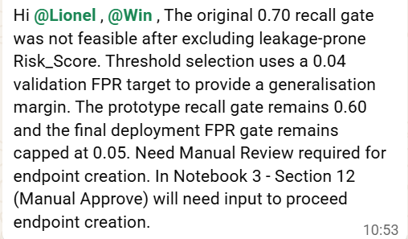
Fig. B.1 — Team communication (24 Aug 2026) confirming the validation-FPR-based threshold rationale (Section 3.4) and the Notebook 03, Section 12 manual-approval requirement before endpoint creation (Section 4.3).
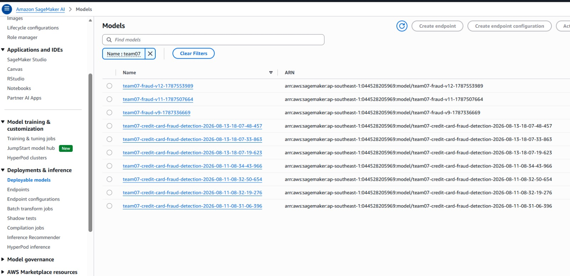
Fig. B.2 — AWS SageMaker Console: Deployable Models for Team07, showing the version history (v9, v11, v12 and intermediate builds) produced by repeated pipeline runs and approvals, 11–24 Aug 2026 (Section 4.4).
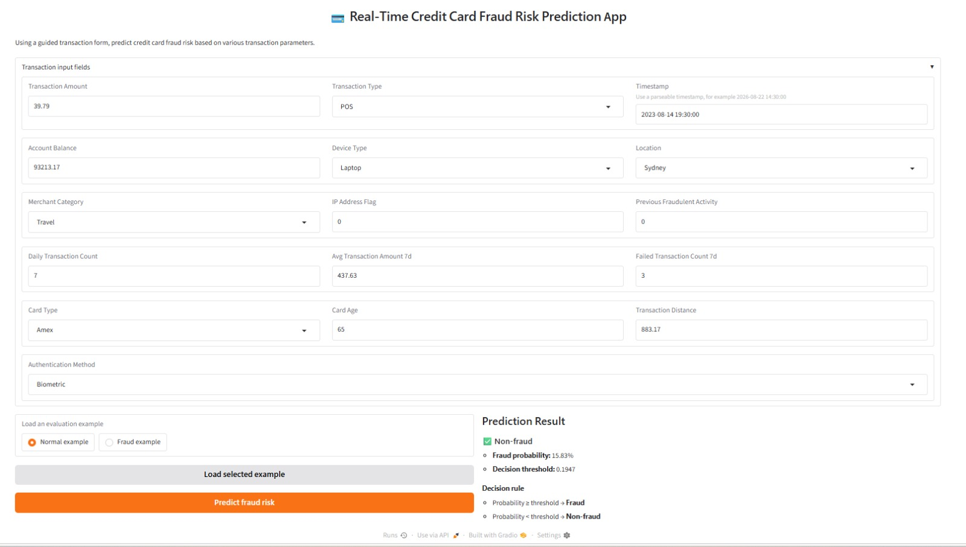
Fig. B.3 — The Real-Time Credit Card Fraud Risk Prediction demo application (Notebook 04), showing a live prediction against the InService endpoint: 15.83% fraud probability vs. the 0.1947 threshold, correctly classified Non-fraud (Section 4.5).
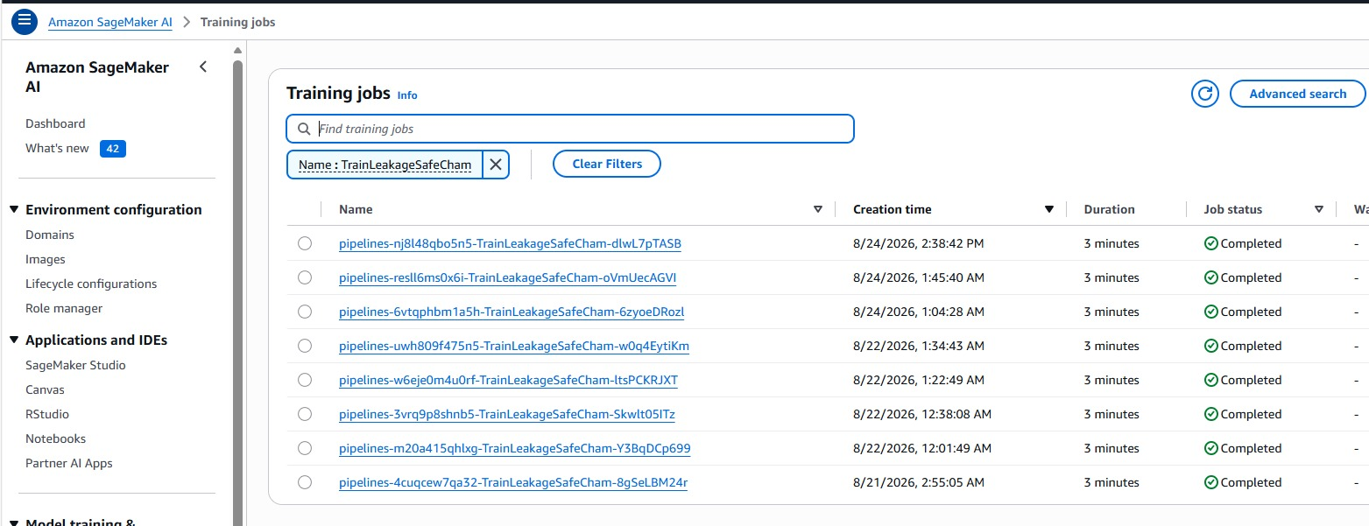
Fig. B.4 — AWS SageMaker Console: Training-job history for the TrainLeakageSafeChampion pipeline step — 8 completed executions, each ~3 minutes, 21–24 Aug 2026, evidencing a repeatable pipeline (Section 4.2).

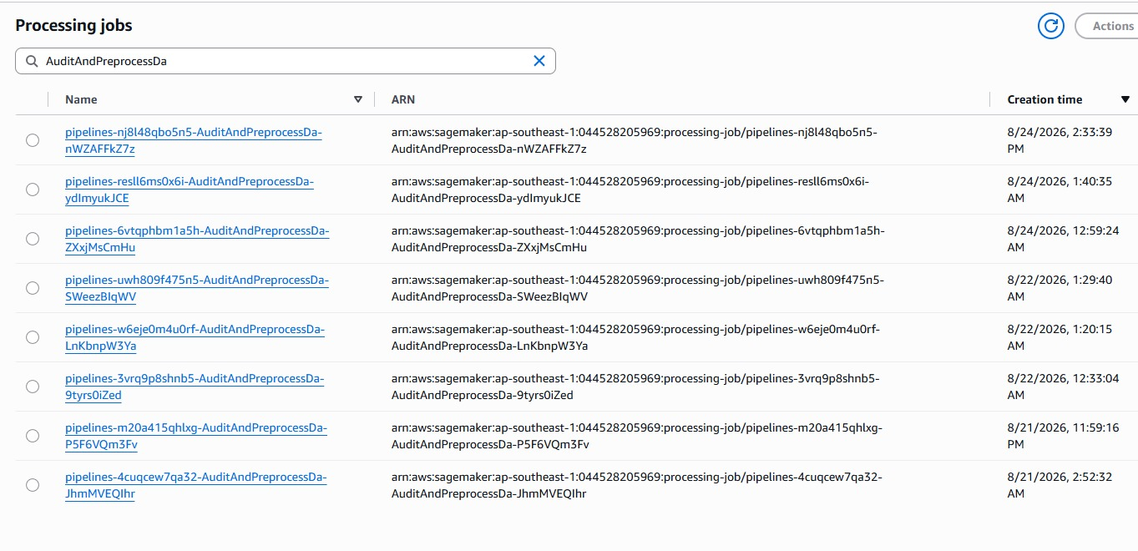
Fig. B.5 — AWS SageMaker Console: Processing-job history for the AuditAndPreprocessData pipeline step, one matching job per pipeline execution shown in Fig. B.4 (Section 4.2).

Appendix C — Notebook and Artefact Inventory
Notebook | Purpose | Key outputs
01 — Setup | Provision/reuse the team's SageMaker MLflow App and validate S3 artefact-store write access | mlflow_app_config_team07_s701.json (shared config consumed by Notebooks 02 & 03)
02 — Experiments | EDA, leakage audit, feature engineering, Model A/B tuning, champion selection, threshold freezing, final test evaluation | team07_best_model.json (champion contract consumed by Notebooks 03, 04 & 05); MLflow runs for all 10 candidates
03 — Pipeline | SageMaker Pipeline (audit → train → register), manual approval, endpoint deployment, live sample-prediction check | Registered model package (v12 approved); live endpoint team07-fraud-v12-endpoint-1787553989
04 — App | Gradio real-time fraud-prediction demo application against the live endpoint | Running Studio-proxied web application (Fig. B.3)
05 — Responsible AI | Fairness (Fairlearn), explainability (SHAP), robustness testing of the deployed champion | responsible_ai_outputs/ (CSV/PNG/JSON evidence referenced in Section 5)

